**How to run Database locally**

Date: 4/13/2013

Authors: Yidu Liang

Xuesong Meng

***1. Download and install MySQL 5.X***

for more detail see:

https://blackboard.neu.edu/courses/1/CSYE7945.31659.201330/db/\_2598527\_1/MySQL%20installation.pdf

***2. Download and install MySQL workbench***

for PC :

 http://dev.mysql.com/downloads/mirror.php?id=412167

 for Mac:

 http://dev.mysql.com/downloads/mirror.php?id=412161

***3. Open MySQL workbench and create new connection***

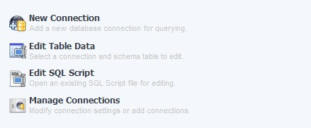

***4. Double click created connection***

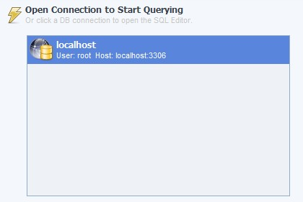

***5. Create new schema in connected server***

C:\Users\yidu1_000\AppData\Roaming\Tencent\Users\974671991\QQ\WinTemp\RichOle\MZ_C7@{YZWA)IHG0}V9B~9K.jpg

name: **ClubUML**

collation: Server Default

then click 'apply'

after that you should see ClubUML on the left

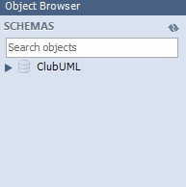

***6. Select Database and create tables***

Double click C:\Users\yidu1_000\AppData\Roaming\Tencent\Users\974671991\QQ\WinTemp\RichOle\V_I)8F5J9EL%F$915V`OLUI.jpg

then, copy text below and paste it to SQL File 1\*, don't forget click execute button on the top (C:\Users\yidu1_000\AppData\Roaming\Tencent\Users\974671991\QQ\WinTemp\RichOle\}NV2R[LV6}8_0R2TL}ZW]VH.jpg)

after that, click refresh C:\Users\yidu1_000\AppData\Roaming\Tencent\Users\974671991\QQ\WinTemp\RichOle\6[$T}3H%A26`QY8B3GECF(H.jpg button and you will see table create successfully:

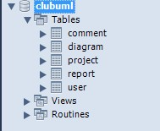

-------------------------------------------------2013.Merge DB create query-----------------------------------------------------

/\*

Created: 2013/2/15

Modified: 2013/3/24

Model: MySQL 5.0

Database: MySQL 5.0

\*/

-- Create tables section -------------------------------------------------

-- Table project

CREATE TABLE project

(

projectId Int(11) NOT NULL AUTO\_INCREMENT,

projectName Varchar(45) NOT NULL,

starDate Varchar(45),

desceiption Varchar(255),

PRIMARY KEY (projectId)

)

;

-- Table user

CREATE TABLE user

(

userId Int(11) NOT NULL AUTO\_INCREMENT,

userName Varchar(45) NOT NULL,

email Varchar(45) NOT NULL,

password Varchar(45) NOT NULL,

securityQ Varchar(60),

securityA Varchar(60),

PRIMARY KEY (userId)

)

;

-- Table diagram

CREATE TABLE diagram

(

diagramId Int(11) NOT NULL AUTO\_INCREMENT,

projectId Int(11) NOT NULL,

userId Int(11) NOT NULL,

diagramType Varchar(45),

diagramName Varchar(45),

createTime Timestamp NULL,

filePath Varchar(45),

fileType Varchar(20),

merged Tinyint,

notationFileName Varchar(45),

notationFilePath Varchar(45),

diFlieName Varchar(45),

diFilepath Varchar(45),

PRIMARY KEY (diagramId)

)

;

-- Table report

CREATE TABLE report

(

reportId Int(11) NOT NULL AUTO\_INCREMENT,

diagramA Int(11) NOT NULL,

diagramB Int(11) NOT NULL,

mergedDiagram Int(11),

type Varchar(20) NOT NULL,

time Timestamp NOT NULL,

reportFilePath Varchar(45) NOT NULL,

reportFileName Varchar(45) NOT NULL,

PRIMARY KEY (reportId)

)

;

-- Table comment

CREATE TABLE comment

(

commentId Int(11) NOT NULL AUTO\_INCREMENT,

userId Int(11),

reportId Int(11),

content Varchar(255),

writenTime Timestamp NULL,

PRIMARY KEY (commentId)

)

;

-- Create relationships section -------------------------------------------------

ALTER TABLE diagram ADD CONSTRAINT diagramHaveOwnerId FOREIGN KEY (userId) REFERENCES user (userId) ON DELETE NO ACTION ON UPDATE NO ACTION

;

ALTER TABLE diagram ADD CONSTRAINT diagramHaveProjectType FOREIGN KEY (projectId) REFERENCES project (projectId) ON DELETE NO ACTION ON UPDATE NO ACTION

;

ALTER TABLE report ADD CONSTRAINT Relationship4 FOREIGN KEY (diagramA) REFERENCES diagram (diagramId) ON DELETE NO ACTION ON UPDATE NO ACTION

;

ALTER TABLE report ADD CONSTRAINT Relationship5 FOREIGN KEY (diagramB) REFERENCES diagram (diagramId) ON DELETE NO ACTION ON UPDATE NO ACTION

;

ALTER TABLE report ADD CONSTRAINT Relationship6 FOREIGN KEY (mergedDiagram) REFERENCES diagram (diagramId) ON DELETE NO ACTION ON UPDATE NO ACTION

;

ALTER TABLE comment ADD CONSTRAINT Relationship7 FOREIGN KEY (userId) REFERENCES user (userId) ON DELETE NO ACTION ON UPDATE NO ACTION

;

ALTER TABLE comment ADD CONSTRAINT Relationship8 FOREIGN KEY (reportId) REFERENCES report (reportId) ON DELETE NO ACTION ON UPDATE NO ACTION

;

-- insert sample data--------------------------------------

insert into project value (1,'clubuml1',now(),'des1');

insert into project value (2,'clubuml2',now(),'des2')